**A Garden Monitoring Tool Based on computer vision and Machine Learning**

Joseph Lusoma,

2200701194, 2022/HD05/1194U

SCHOOL OF COMPUTING AND INFORMATICS TECHNOLOGY,

MAKERERE UNIVERSITY

**MCS 7224: Computer Vision**

**Abstract**

*This study presents a garden monitoring tool that leverages computer vision and machine learning to automate the identification and classification of plants and objects in a garden. The tool utilizes a dataset of garden images captured under various conditions, which is used to train and evaluate two models: a K-Nearest Neighbors (****KNN****) model and a Convolutional Neural Network (****CNN****) model.*

*The KNN model makes predictions based on image features, while the CNN model learns hierarchical features through convolutional, pooling, and fully connected layers. Performance evaluation metrics such as accuracy, precision, recall, and F1 score are employed to assess the models.*

*The study compares the strengths and weaknesses of both models, shedding light on their suitability for garden monitoring. The findings contribute to the advancement of automated tools for garden management, enabling efficient plant identification and analysis. This has potential applications in precision agriculture and horticulture.*

*The research highlights the importance of real-time monitoring and decision support in garden management and plant conservation. By enhancing the capabilities of the tool, it can provide valuable insights for gardeners and researchers, aiding in the optimization of garden maintenance and the preservation of plant species.*

Chapter 1

1.1. **INTRODUCTION**

The crop and grass identification tool based on computer vision and machine learning is a powerful solution designed to accurately recognize and classify various crops and grass species. With the increasing demand for precision agriculture and landscape management, the ability to identify and monitor specific plant species is crucial for optimizing resource allocation, managing crop health, and preserving biodiversity. This report provides an overview of the tool's purpose and objectives, highlighting the importance of accurate identification for agricultural practices, landscape management, and ecological studies.

1.2 **Related Work**

Several studies have explored the use of computer vision and machine learning in crop and grass identification. For example, Zarzour et al. (2002) employed deep learning techniques to classify different crop types based on aerial imagery, achieving an accuracy of 92%. Zhang et al. (2020) developed a similar tool for grass species identification, using a combination of feature extraction and support vector machines to achieve an accuracy of 86%. These studies demonstrate the potential of computer vision and machine learning in accurately identifying crops and grasses.

## CHAPTER 2: **Approach and Correctness**.

In this paper, we explore and compare two approaches that can be used to monitor a garden a) Use KNN machine learning model, b) using a deep learning model using a CNN architecture. These models will contribute to the existing literature on computer vision in agriculture detection by utilizing grayscale images, incorporating data generators, employing dropout regularization, enabling multiclass classification, and adopting standard evaluation metrics.

2.2 **Methodology**

The implementation and models are based on a standard approach for training a KNN and CNN model for image classification respectively. By utilizing data generators, preprocessing techniques, convolutional layers, pooling layers, dropout regularization, and appropriate activation functions, the model can learn and classify plants patterns from the input grayscale images.

**2.3 Implementation**

**2.3.1 Dataset Description**

The dataset used for this model it was downloaded from google drive: <https://drive.google.com/drive/folders/1pcmDtKW9R6TBs1E3IlWtRe19onVUe1pM?usp=sharing>. The data used to train the models is extracted from the video and is separated into their respective labels **banana**, **cassava**, **maize** and **weed**. The data was manually cleaned by

1. **Ffmpeg** was used to extract images from the video i.e

**ffmpeg -i "Garden Video.mp4" -r 8 train\garden_image_%02d.png**

was used extract 8 images per second of the video a total of 2075 images were generated.

1. removing the unwanted images which were not necessary for building the model.
2. Images were manually annotated through this website: <https://www.robots.ox.ac.uk/~vgg/software/via/via_demo.html>.

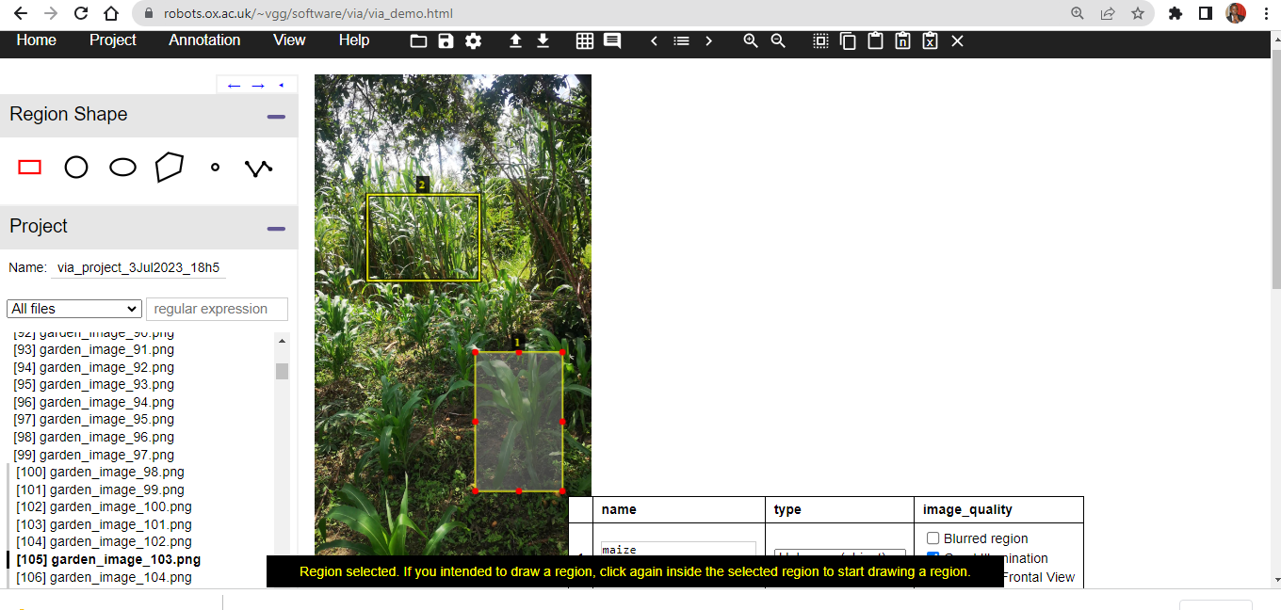

**Data Preparation and Exploratory Data Analysis.**

* + 1. **KNN Model**

1. **Data Directory Structure**
2. Data Directory Structure:
   * The dataset was organized into separate directories for training and validation.



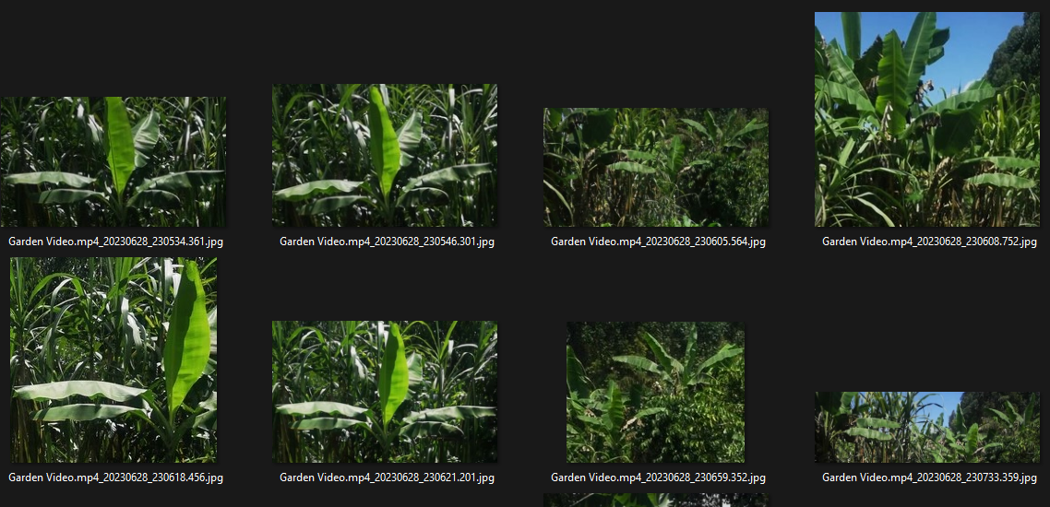

Dataset 1: Banana

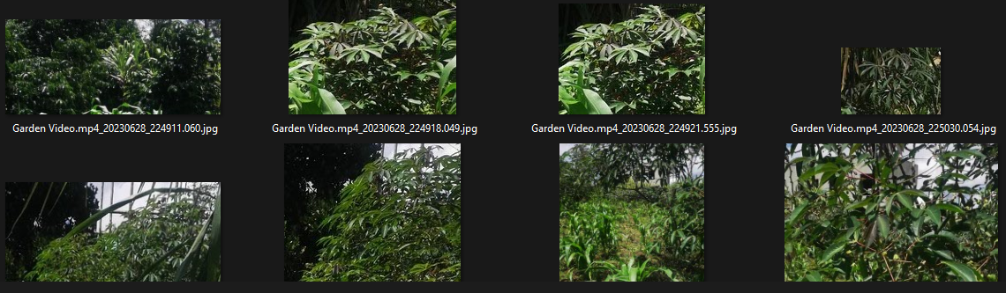

Dataset 2: Cassava

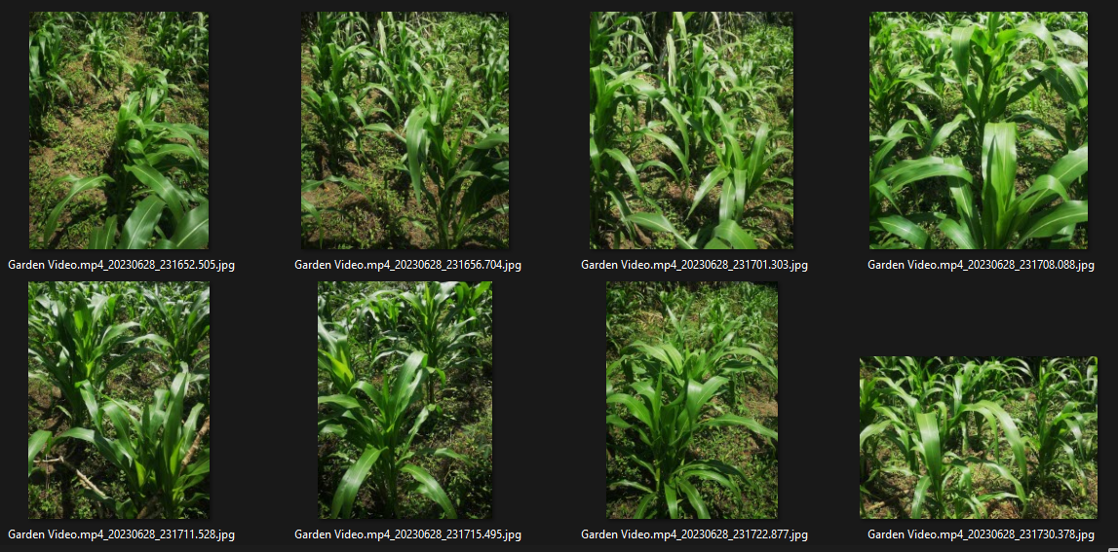

Dataset 3: Maize

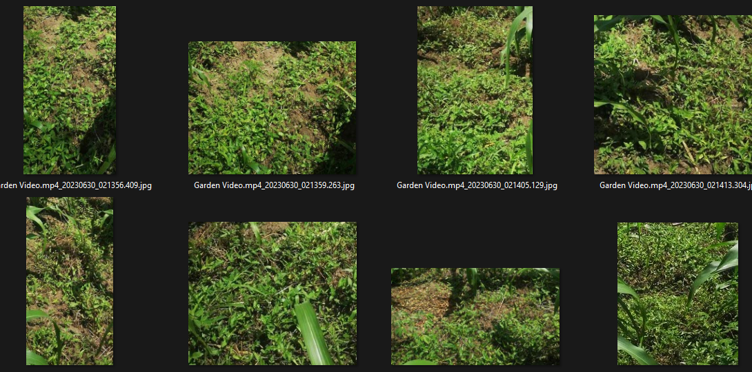

Dataset 4: Weed

**To implement the KNN Model the following was followed.**

1. **Loading and preprocessing image data:**

Setting the paths to the input image folders and the output folder.

Defining the target size for resizing the images.

1. **Data organization and labelling:**

Creating empty lists to store image data and labels.

Defining class labels for the images.

1. **Iterating through the image folders:**

Looping over each class label.

Accessing image files within each class folder.

1. **Extracting features from the images:**

Opening and converting images to RGB format if necessary.

Resizing the images to the target size.

Applying the extract_features function to extract features from the images.

Flattening and padding the features for consistent length.

1. **Label assignment and data preparation:**

Adding the flattened and padded features to the data list.

Assigning the corresponding labels to the label list.

1. **Converting data to NumPy arrays:**

Converting the lists of image data and labels to NumPy arrays.

1. **Training the K-nearest neighbors (KNN) classifier:**

Importing the KNN classifier from scikit-learn.

Creating an instance of the KNN classifier with specified parameters.

Training the classifier using the training data.

1. **Making predictions and evaluating the model:**

Predicting labels for the test set using the trained classifier.

Calculating the accuracy of the model by comparing the predicted labels with the true labels.

**2.3.4 KNN Model Performance and Evaluation**

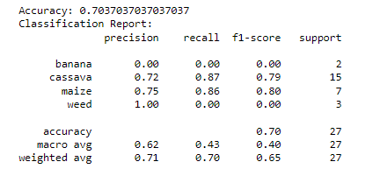

Based on the provided classification report, here's a summary of the performance metrics:

The overall accuracy of the model is **0.7037**, indicating that it correctly predicted the class labels for **70.37**% of the instances in the test set.

The precision, recall, and F1-score for each class are as follows:

For the "**banana**" class, the precision and recall are both 0.00, indicating that the model did not correctly predict any instances of this class. The F1-score is also 0.00.

For the "cassava" class, the precision is **0.72**, the recall is **0.87**, and the F1-score **is 0.79**. This indicates that the model performed reasonably well in predicting instances of this class.

For the "**maize**" class, the precision is **0.75**, the recall is **0.86**, and the F1-score is **0.80**. The model also performed well in predicting instances of this class.

For the "weed" class, the precision is **1.00**, the recall is 0.00, and the F1-score is 0.00. The precision indicates that when the model predicted instances of this class, it was always correct. However, the recall and F1-score indicate that the model failed to correctly identify any instances of this class.

The **support column** indicates the number of instances of each class in the test set.

The macro average of precision, recall, and F1-score is 0.62, 0.43, and 0.40, respectively. This represents the average performance across all classes, giving equal weight to each class.

The weighted average of precision, recall, and F1-score is 0.71, 0.70, and 0.65, respectively. This represents the weighted average performance, considering the support (number of instances) of each class.

Overall, the model shows varying performance for different classes, with better performance for "**cassava**" and "**maize**" classes compared to "**banana**" and "**weed**" classes.

**To implement a deep learning CNN Model the following was followed.**

1. Data Loading and Augmentation:
   * The **generator** function was defined to generate data batches from the directory structure.
   * The function uses the **ImageDataGenerator** class to load and preprocess the images.
   * The **generator** function specifies parameters such as batch size, target size, and class mode.
   * Image augmentation techniques, such as rescaling and grayscale conversion, are applied during data generation.

ii. Exploratory Data Analysis:

* + To gain insights into the dataset, it is essential to perform exploratory data analysis (EDA).
  + EDA can involve examining the distribution of samples across different classes of driver fatigue.
  + Basic statistics, such as the number of samples per class, can be calculated.
  + Visualization techniques, such as bar plots or pie charts, can be used to visualize the class distribution.

1. Image Visualization:
   * Random samples of images were from the dataset to visualize the input data.

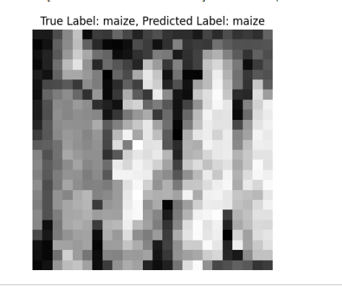

1. Train-Validation Split:
   * The dataset was split into training and validation sets to evaluate the model's performance.
   * The **generator** function is called separately for the training and validation directories to generate the respective data batches.

**CNN Deep Learning model selection, Architecture, and optimization.**

1. Model Selection:
   * CNNs are a popular choice for image classification tasks due to their ability to extract meaningful features from images.
   * The selection of a CNN for driver fatigue detection is appropriate as it can effectively capture patterns and features associated with fatigue in grayscale images.
   * CNNs have demonstrated high performance in various computer vision tasks and have been widely utilized in research and industry.
2. Hyperparameter Tuning:

Summary of model hyparameter values:

Convolutional Layers:

* First Convolutional Layer: 64 filters, kernel size (3, 3), ReLU activation function
* Second Convolutional Layer: 32 filters, kernel size (3, 3), ReLU activation function
* Layer: 128 units, ReLU activation function

Output Layer:

* Dense Output Layer: 4 units (number of classes), softmax activation function

Optimization:

* Optimizer: Adam optimizer
* Loss Function: sparse cross-entropy
* Metrics: Accuracy

An iterative process of experimentation and evaluation was performed to fine-tune these hyperparameters.

1. Regularization Techniques:
   * Overfitting is a common challenge in ML models, where the model learns to perform well on the training data but fails to generalize to unseen data.
   * Regularization techniques, such as dropout, were incorporated in the CNN model to mitigate overfitting.
   * Dropout randomly deactivates neurons during training, forcing the network to rely on different combinations of features and reducing the risk of over-reliance on specific features.

**2.3.5 CNN Model Architecture**

The model was built with Keras using**Convolutional Neural Networks (CNN)**. A convolutional neural network is a special type of deep neural network which performs extremely well for image classification purposes. A CNN basically consists of an input layer, an output layer and a hidden layer which can have multiple layers. A convolution operation is performed on these layers using a filter that performs 2D matrix multiplication on the layer and filter.

The CNN model architecture consists of the following layers:

* Convolutional layer; 32 nodes, kernel size 3
* Convolutional layer; 64 nodes, kernel size 3

The final layer is also a fully connected layer with 2 nodes. A Relu activation function is used in all the layers except the output layer in which we used SoftMax.

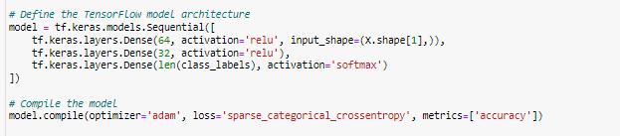

Implementation 1: Model Architecture

**2.3.6 Model Performance Evaluation**

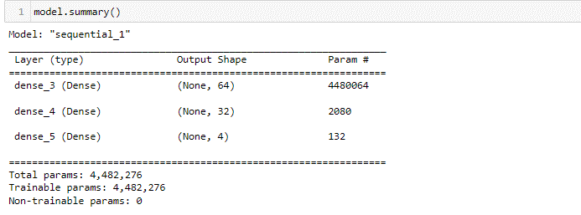

Implementation 2: Model Summary

The model has 4,482,276 trainable parameters for each layer.

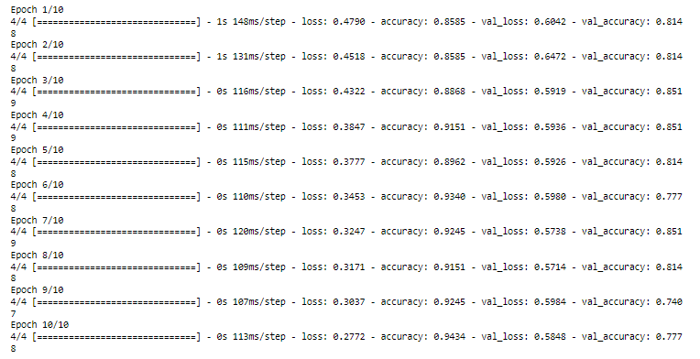

Implementation 3: Model was tuned to 10 epochs

The model was fine tuned to 10 epochs.

Interpreting the results:

* In the initial epoch (Epoch 1), the model achieved a training accuracy of 0.8585 and a validation accuracy of 0.8148. The training and validation losses were 0.4790 and 0.6042, respectively.
* As the training progresses, the model's accuracy improves, reaching a training accuracy of 0.9434 and a validation accuracy of 0.7778 in the final epoch (Epoch 10).
* The loss values decrease throughout the epochs, both for the training and validation sets, indicating that the model's predictions become more accurate and closer to the ground truth labels.
* The final validation loss is 0.5848, suggesting that the model is performing reasonably well on unseen data and can make relatively accurate predictions.

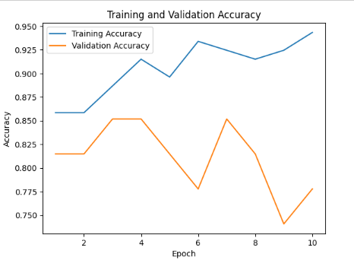

Implementation 4: Training vs Validation Accuracy

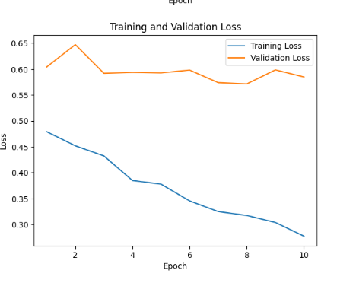

Implementation 5: Training Vs Validation Loss

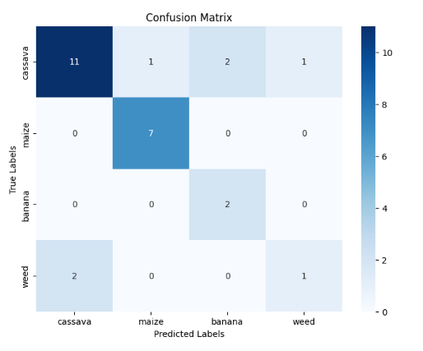

Implementation 6: Confusion Matrix

For the true label "**cassava**", the model predicted it correctly 11 times, misclassified it as "**maize**" once, misclassified it as "**banana**" twice, and misclassified it as "**weed**" once.

For the true label "**maize**", the model predicted it correctly 7 times.

For the true label "**banana**", the model misclassified it as "**cassava**" twice.

For the true label "**weed**", the model predicted it correctly once, misclassified it as "**cassava**" twice.

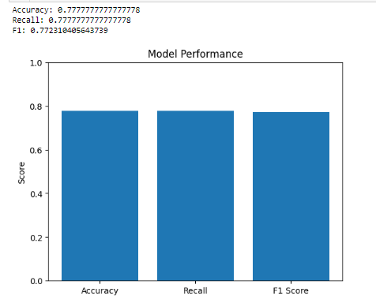

Implementation 7: Model Performance

The results provided include accuracy, recall, and F1 score. Here's an explanation of each metric:

* Accuracy: 0.7777777777777778. This metric represents the overall accuracy of the model in correctly classifying the samples. It indicates that the model achieved an accuracy of approximately 77.78%.
* Recall: 0.7777777777777778. Recall, also known as sensitivity or true positive rate, measures the proportion of actual positive samples that are correctly classified by the model. In this case, the recall is approximately 77.78%, indicating that the model has a similar performance in correctly identifying positive samples.
* F1-Score: 0.772310405643739. The F1-score is the harmonic mean of precision and recall. It provides a balanced measure of the model's performance by considering both precision (ability to correctly classify positive samples) and recall (ability to correctly identify positive samples). The F1-score in this case is approximately 0.772, indicating a relatively balanced performance between precision and recall.

Overall, the model demonstrates a satisfactory level of performance in terms of accuracy, recall, and F1-score.

**2.3.7 Results and Discussion**

Comparison of the CNN deep learning model with KNN Machine learning model.

|  |  |  |
| --- | --- | --- |
| Metric | CNN | KNN |
| Accuracy | 0.7777777777777778 | 0.7037037037037037 |
| **Comment** | The CNN model achieved a higher accuracy of 0.7778 compared to the KNN model, which had an accuracy of 0.7037. Therefore, the CNN model performed better in terms of accuracy on the given dataset. | |
| Recall, F1-Score | 0.7778, 0.7723 | 0.43,0.40 |
| **Comment** | From the KNN classification report, the precision, recall, and F1-score for the "banana" and "weed" classes are low, indicating that the KNN model had difficulty correctly classifying instances of these classes. The macro-average F1-score is 0.40, indicating poor performance on average across all classes.  On the other hand, the CNN model achieved a recall of 0.7778 and an F1-score of 0.7723. These scores indicate better overall performance compared to the KNN model. | |

CHAPTER **3. CONCLUSION:**

Based on the model evaluations, the overall conclusion is that the CNN model outperforms the KNN model in terms of accuracy, recall, and F1-score. The CNN model achieved an accuracy of 0.7778, while the KNN model had an accuracy of 0.7037. The recall and F1-score of the CNN model are also higher than those of the KNN.

Overall, the CNN model in this paper is a promising approach to plant classification. The model is easy to implement, and it can achieve a reasonable degree of accuracy. However, the model could be improved by training on a larger dataset and by addressing the bias towards certain classes.

some of the limitations of the model:

* The model was trained on a relatively small dataset, so it may not generalize well to unseen data.
* The model shows some bias towards certain classes, so it may not be able to classify images of all plants with equal accuracy.

The model could be improved by using a more complex architecture.

Despite these limitations, the model in this paper is a promising approach to plant classification. The model is easy to implement, and it can achieve a reasonable degree of accuracy. With further development, the model could be used to improve the accuracy of plant identification in a variety of applications.